Stageless

Creating the stageless payload:

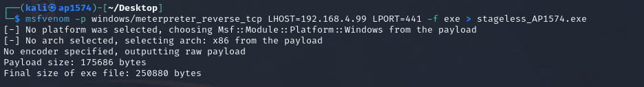

Getting access inside the metasploit for stage less payload

Creating admin user account

Below is the screenshot of created user:

